Lab - Configure IPv6 Addresses on Network Devices

# Topology



# Addressing Table

|  |  |  |  |  |
| --- | --- | --- | --- | --- |
| Device | Interface | IPv6 Address | Prefix Length | Default Gateway |
| R1 | G0/0/0 | 2001:db8:acad:a::1 | 64 | N/A |
| R1 | G0/0/1 | 2001:db8:acad:1::1 | 64 | N/A |
| S1 | VLAN 1 | 2001:db8:acad:1::b | 64 | N/A |
| PC-A | NIC | 2001:db8:acad:1::3 | 64 | fe80::1 |
| PC-B | NIC | 2001:db8:acad:a::3 | 64 | fe80::1 |

# Objectives

Part 1: Set Up Topology and Configure Basic Router and Switch Settings

Part 2: Configure IPv6 Addresses Manually

Part 3: Verify End-to-End Connectivity

# Background / Scenario

In this lab, you will configure hosts and device interfaces with IPv6 addresses. You will issue **show** commands to view IPv6 unicast addresses. You will also verify end-to-end connectivity using **ping** and **traceroute** commands.

# Instructions

## Cable the Network and Configure Basic Router and Switch Settings

After cabling the network, initializing and reloading the router and switch, complete the following:

### Configure the router.

Assign the hostname and configure basic device settings.

### Configure the switch.

Assign the hostname and configure basic device settings.

## Configure IPv6 Addresses Manually

### Assign the IPv6 addresses to Ethernet interfaces on R1.

* + - 1. Assign the IPv6 global unicast addresses, listed in the Addressing Table, to both Ethernet interfaces on R1.

R1(config)# **int g0/0/0**

R1(config)# **ipv6 address 2001:db8:acad:a::1/64**

R1(config)# **no shut**

Do same for G0/0/1

Open configuration window

* + - 1. Verify that the correct IPv6 unicast address is assigned to each interface.

R1# **sh ipv6 int br**

Record the Link Local addresses for G0/0/0 & G0/0/1:

**G0/0/0 Link Local : FE80::BED2:95FF:FEA1:1E30**

**G0/0/1 Link Local : FE80::BED2:95FF:FEA1:1E31**

**Note**: The link-local address (fe80::) displayed is based on EUI-64 addressing, which automatically uses the interface Media Access Control (MAC) address to create a 128-bit IPv6 link-local address.

* + - 1. To get the link-local address to match the global unicast address on the interface, manually enter the link-local addresses on each of the Ethernet interfaces on R1.

**Note**: Each router interface belongs to a separate network. Packets with a link-local address never leave the local network; therefore, you can use the same link-local address on both interfaces.

R1(config)# **int g0/0/0**

R1(config)# **ipv6 address fe80::1 link local**

R1(config)# **no shut**

Do same for G0/0/1

* + - 1. Use a command of your choice to verify that the link-local address has been changed to **fe80::1.**

Close a configuration window

#### Question:

Which two multicast groups have been assigned to interface G0/0/0? (sh ipv6 g0/0/0)

FF02::1

FF02::1:FF00:1

Type your answers here.

### Enable IPv6 routing on R1.

* + - 1. On a PC-B command prompt, enter the **ipconfig** command to examine IPv6 address information assigned to the PC interface.

#### Question:

Has an IPv6 unicast address been assigned to the network interface card (NIC) on PC-B?

Not yet

* + - 1. Enable IPv6 routing on R1 using the **IPv6 unicast-routing** command.

Now it does

Open configuration window

* + - 1. Use a command to verify the new multicast group are assigned to interface G0/0/0. Notice that the all-router multicast group (FF02::2) now appears for interface G0/0/0.

FF02::1

FF02::2

FF02::1:FF00:1

**Note**: This will allow the PCs to obtain their IP address and default gateway information automatically using Stateless Address Autoconfiguration (SLAAC).

* + - 1. Now that R1 is part of the all-router multicast group ff02::2, re-issue the **ipconfig** command on PC-B and examine the IPv6 address information.

#### Question:

Why did PC-B receive the Global Routing Prefix and Subnet ID that you configured on R1?

Because of EUI-64

### Assign IPv6 addresses to the management interface (SVI) on S1.

* + - 1. Assign the IPv6 address for S1. Also assign a link-local address for this interface.
      2. Use a command of your choice to verify that the IPv6 addresses are properly assigned to the management interface.

S1(config)# **int vlan 1**

S1(config)# **ipv6 address 2001:db8:acad:1::b/64**

S1(config)# **no shut**

Close a configuration window

### Assign static IPv6 addresses to the PCs.

* + - 1. Open the Ethernet Propertieswindow on for each PC and assign IPv6 addressing.
      2. Verify both PCs have the correct IPv6 address information. Each PC should have two Global IPv6 addresses: one static and one SLACC

## Verify End-to-End Connectivity

From PC-A,ping **fe80::1**. This is the link-local address assigned to G0/0/1 on R1.

Ping the S1 management interface from PC-A.

Use the **tracert** command on PC-A to verify that you have end-to-end connectivity to PC-B.

From PC-B, ping PC-A. (Insert a screen Shot)

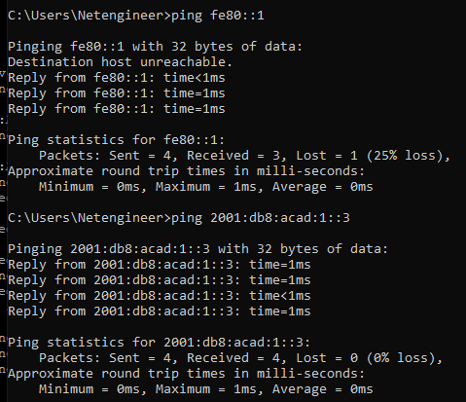

From PC-B, ping the link-local address for G0/0/0 on R1.

**Note**: If end-to-end connectivity is not established, troubleshoot your IPv6 address assignments to verify that you entered the addresses correctly on all devices.

# Reflection Questions

* 1. Why can the same link-local address, fe80::1, be assigned to both Ethernet interfaces on R1?

Because it’s a link local address, the local networks are connected to router 1 but will not see one another.

* 1. What is the Subnet ID of the IPv6 unicast address 2001:db8:acad::aaaa:1234/64?

The subnet ID is a

Type your answers here.